Michael Ghisilieri

CPE301 – SPRING 2016

Design Assignment 5

**DO NOT REMOVE THIS PAGE DURING SUBMISSION:**

The student understands that all required components should be submitted in complete for grading of this assignment.

|  |  |  |  |
| --- | --- | --- | --- |
| **NO** | **SUBMISSION ITEM** | **COMPLETED (Y/N)** | **MARKS**  **(/MAX)** |
| 0. | COMPONENTS LIST AND FLOW CHART OF EACH TASK |  |  |
| 1. | INITIAL CODE OF TASK 1 |  |  |
| 2. | INITIAL CODE OF TASK 2 |  |  |
| 3. | INITIAL CODE OF TASK 3 |  |  |
| 4. | SCHEMATICS |  |  |
| 5. | SCREENSHOTS OF EACH TASK OUTPUT |  |  |
| 6. | SCREENSHOT OF EACH DEMO |  |  |
| 7. | VIDEO LINKS OF EACH DEMO |  |  |
| 8. | GITHUB LINK OF THE DA |  |  |
|  |  |  |  |
|  |  |  |  |

|  |  |  |  |
| --- | --- | --- | --- |
| 0. | COMPONENTS LIST AND CONNECTION BLOCK DIAGRAM w/ PINS |  |  |

**COMPONENTS:**

|  |  |  |
| --- | --- | --- |
| **Task 1** | **Task 2** | **Task 3** |
| ATmega328P x1 | ATmega328P x1 | ATmega328P x1 |
| 2.5k Ω potentiometer x1 | 2.5k Ω potentiometer x1 | 2.5k Ω potentiometer x1 |
| 330 Ω resistor x1 | ULN2003A x1 | Servo Motor x1 |
| 10k Ω resistor x1 | Stepper Motor x1 |  |
| 100k Ω resistor x1 |  |  |
| ILD74 x1 |  |  |
| TIP120 x1 |  |  |
| 1N4004 x1 |  |  |
| 0.1 µF x1 |  |  |
| DC Motor x1 |  |  |

**FLOWCHARTS:**

TASK 1:

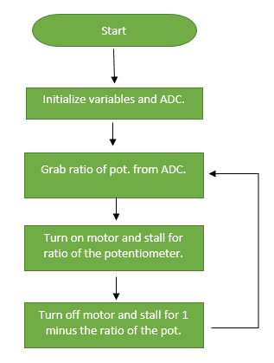

TASK 2:

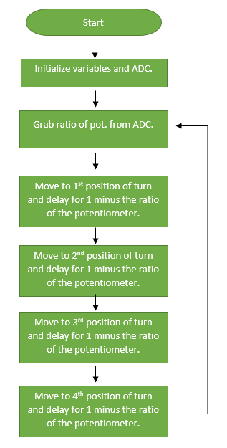

TASK 3:

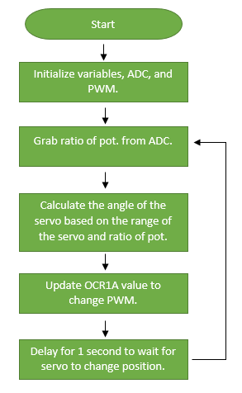

|  |  |  |  |
| --- | --- | --- | --- |
| 1. | INITIAL CODE OF TASK 1 |  |  |

/*

* DA5_Task1.c

*

* Created: 4/6/2016 4:32:27 PM

* Author : Michael

*/

#define *F_CPU* 8000000UL //XTAL = 8MHZ

#include <avr/io.h> // library for I/O

#include <util/delay.h> // library for _delay_ms() function

#include <avr/sfr_defs.h> // library for loop_until_bit_is_clear function

void delay(unsigned short); // function to delay

int main()

{

unsigned short potValue; // will hold value of pot. from ADC

unsigned short period = 50; // total period of 50ms

ADMUX |= (1 << REFS0); // AVcc with ext. cap. at AREF pin

// ADCSRA will set prescaler to 8 and enable ADC

ADCSRA |= (1 << ADEN) | (1 << ADPS1) | (1 << ADPS0);

DDRB = 0x01; // set PB0 as output

PORTB = 0; // DC motor will always be on

// the value used for stall ratios is 0.000975 which is actually

// 1/1023 where 1023 is the max value of the 10-bit ADC

// so the equation will be (value from pot. * 1/1023) or

// (1 - (value from pot. * 1/1023)

while(1)

{

ADCSRA |= (1 << ADSC); // start ADC conversion

loop_until_bit_is_clear(ADCSRA, ADSC); // wait until ADC is done

potValue = ADC; // store ADC value into potValue

if (potValue == 0) // if potentiometer is turned completely off

PORTB = 1; // turn DC motor off

else {

// these two stalls will essentially be 75% on and (1 - 75%) = 25% if

// the value of the potentiometer was turned 75% of the way

PORTB = 0; // turn DC motor on

delay((unsigned short)(period * (potValue*(.000975)))); // stall for ratio of pot.

PORTB = 1; // turn DC motor off

delay((unsigned short)(period * (1 - (potValue*(.000975))))); // stall for (1 - ratio of pot.)

}

}

return 0 ;

}

void delay(unsigned short count) // count will be delay time in ms

{

int i; // variable for for-loop iterations

for(i = 0; i < count; i++)

*_delay_ms*(1); // 1ms delay * count

}

|  |  |  |  |
| --- | --- | --- | --- |
| 2. | INITIAL CODE OF TASK 2 |  |  |

/*

* DA5_Task2.c

*

* Created: 4/7/2016 5:15:29 PM

* Author : Michael

*/

#define *F_CPU* 8000000UL //XTAL = 8MHZ

#include <avr/io.h> // library for I/O

#include <util/delay.h> // library for _delay_ms() function

#include <avr/sfr_defs.h> // library for loop_until_bit_is_clear function

void delay(unsigned short); // function to delay

int main()

{

unsigned short potValue; // will hold value of pot. from ADC

unsigned short period = 50; // total period of 50ms

ADMUX |= (1 << REFS0); // AVcc with ext. cap. at AREF pin

// ADCSRA will set prescaler to 8 and enable ADC

ADCSRA |= (1 << ADEN) | (1 << ADPS1) | (1 << ADPS0);

DDRB = 0xFF; // set all of PORTB as output

// the value used for stall ratios is 0.000975 which is actually

// 1/1023 where 1023 is the max value of the 10-bit ADC

// so the equation will be (value from pot. * 1/1023) or

// (1 - (value from pot. * 1/1023)

while(1)

{

ADCSRA |= (1 << ADSC); // start ADC conversion

loop_until_bit_is_clear(ADCSRA, ADSC); // wait until ADC is done

potValue = ADC; // store ADC value into potValue

// green, red, black, blue

if (potValue == 0) // if potentiometer is turned completely off

// stepper will not move and stay in place

PORTB = PORTB;

// These values being output to PORTB will cause

// the coils to spin the motor in a clockwise direction

// 0x06 = 0110 which will mean give the wires

// green = 0, red = 1, black = 1, blue = 0

else {

// Since turning the potentiometer to a higher value, it should

// cause the speed to increase which will mean a smaller delay

// with the function delay(). This is why I delay with the

// equation (1-ratio) since a higher value will delay for less

// result in a faster speed.

PORTB = 0x06;

delay((unsigned short)(period * (1- (potValue*(.000975)))));

PORTB = 0x0C;

delay((unsigned short)(period * (1- (potValue*(.000975)))));

PORTB = 0x09;

delay((unsigned short)(period * (1- (potValue*(.000975)))));

PORTB = 0x03;

delay((unsigned short)(period * (1- (potValue*(.000975)))));

}

}

return 0;

}

void delay(unsigned short count) // count will be delay time in ms

{

int i; // variable for for-loop iterations

for(i = 0; i < count; i++)

*_delay_ms*(1); // 1ms delay * count

}

|  |  |  |  |
| --- | --- | --- | --- |
| 3. | INITIAL CODE OF TASK 3 |  |  |

/*

* DA5_Task3.c

*

* Created: 4/7/2016 6:15:26 PM

* Author : Michael

*/

// brown = ground

// red = power

// orange = PWM

#define *F_CPU* 8000000UL // clock frequency for delay

#include <util/delay.h> // library for _delay_ms() function

#include <avr/io.h> // library for I/O

#include <avr/sfr_defs.h> // library for loop_until_bit_is_clear function

void delay (); // function declaration for delay

int main()

{

unsigned short potValue; // will hold value of pot. from ADC

unsigned short angle = 0; // angle of servo motor

ADMUX |= (1 << REFS0); // AVcc with ext. cap. at AREF pin

// ADCSRA will set prescaler to 8 and enable ADC

ADCSRA |= (1 << ADEN) | (1 << ADPS1) | (1 << ADPS0);

DDRB = 0x02; // PB1/OC1A as output to PWM of servo

//ICR1 = 20000 defines 50Hz PWM

ICR1 = 20000; // value that timer will catch on interrupt

// TCCR1A will toggle on compare match, Fast PWM with ICR1 as top value

TCCR1A|=(0<<COM1A0)|(1<<COM1A1)|(0<<COM1B0)|(0<<COM1B1)|(1<<WGM11)|(0<<WGM10);

// prescaler of 8

TCCR1B|=(0<<ICNC1)|(0<<ICES1)|(1<<WGM13)|(1<<WGM12)|(0<<CS12)|(1<<CS11)|(0<<CS10);

// the value used for angle ratio is 0.000975 which is actually

// 1/1023 where 1023 is the max value of the 10-bit ADC

// so the equation will be (1 - (value from pot. * 1/1023))

// to match the way at which this specific servo rotates

while(1)

{

ADCSRA |= (1 << ADSC); // start ADC conversion

loop_until_bit_is_clear(ADCSRA, ADSC); // wait until ADC is done

potValue = ADC; // store ADC value into potValue

// Since the range from 0 degrees to 180 degrees is the

// max value minus the minimum, it will be 2300 - 500 = 1800

// multiple the range by the potentiometer ratio

angle = 1800*(1 - (potValue*(.000975)));

angle += 500; // add 500 since 0 degrees is at 500

OCR1A = angle; // set OCR1A to calculated value based on pot.

delay(); // delay for 1 second

}

}

void delay () {

int i; // declare i for counter

for(i = 0; i < 100; i++) { // loop 100 times

*_delay_ms*(10); // delay 10 ms

} // total delay = 100*10ms = 1000ms

}

|  |  |  |  |
| --- | --- | --- | --- |
| 4. | SCHEMATICS |  |  |

TASK 1:

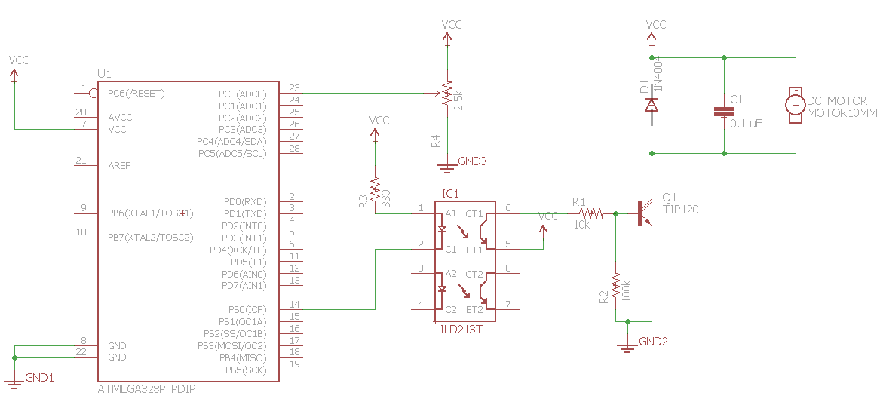

TASK 2:

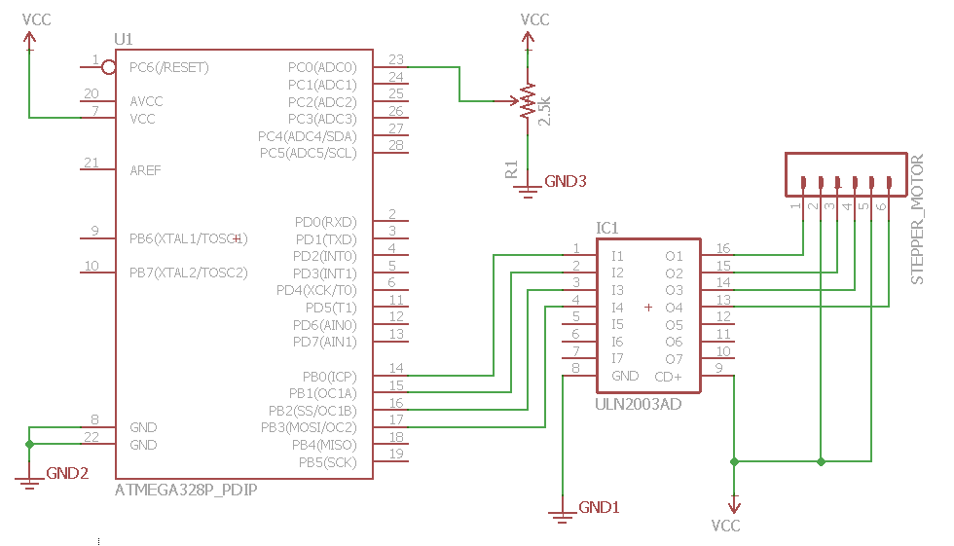

TASK 3:

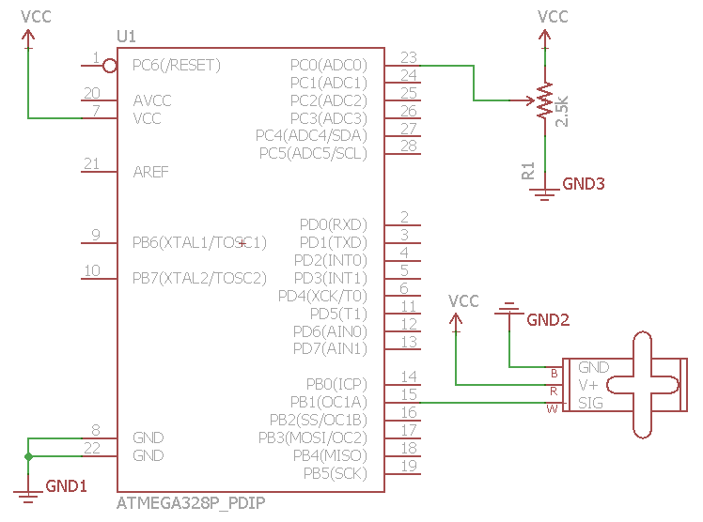

|  |  |  |  |
| --- | --- | --- | --- |
| 5. | SCREENSHOTS OF TASK OUTPUT |  |  |

TASK 1/2: These simulation shots show that the ratio for stalls are in fact calculated correctly. Our total stall time is set to 50ms in the code. The total delay will be ≈ 50ms that are actually used/calculated.

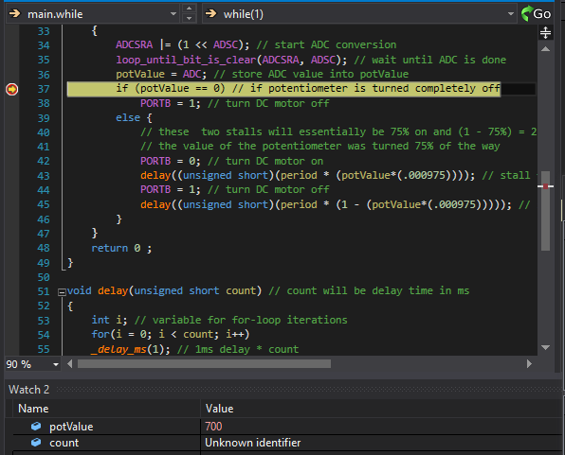

If the potentiometer gives a value of 700 to the ADC, the value for the first stall **(period * (potValue*(.000975)))** will equal **(50 * (700*(.000975))) ≈ 34ms** shown in the count register of the delay function.

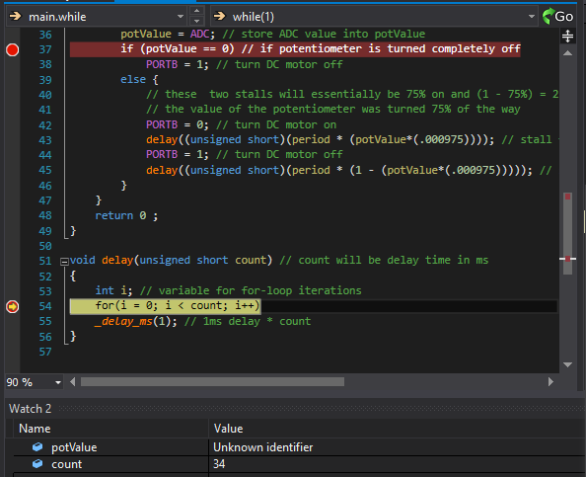

If the potentiometer gives a value of 700 to the ADC, the value for the second stall **1 - (period * (potValue*(.000975)))** will equal **1- (50 * (700*(.000975))) ≈ 15ms** shown in the count register of the delay function.

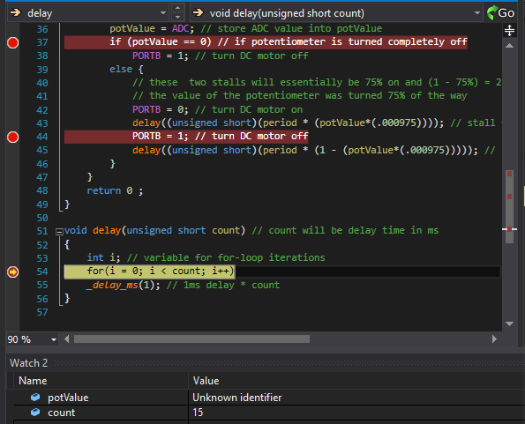

TASK 3: Now if the third task is given a potentiometer value of 700, the value being loaded into OCR1A for the PWM of the servo will be calculated as **500 + 1800*(1-potValue*(.000975))** which will end up being **500 + 1800*(1-potValue*(.000975)) ≈ 1071**. The reason that I used (1 minus the ratio) instead of just the ratio itself is because the servo is all the way to the right at 0 degrees. To make the servo look like it’s at the same position of the potentiometer, I “flipped” the ratio so they are turning together.

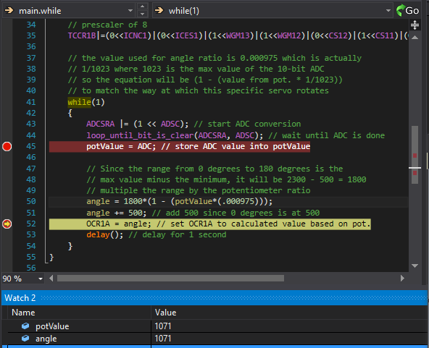

|  |  |  |  |
| --- | --- | --- | --- |
| 6. | SCREENSHOT OF EACH DEMO |  |  |

TASK 1:

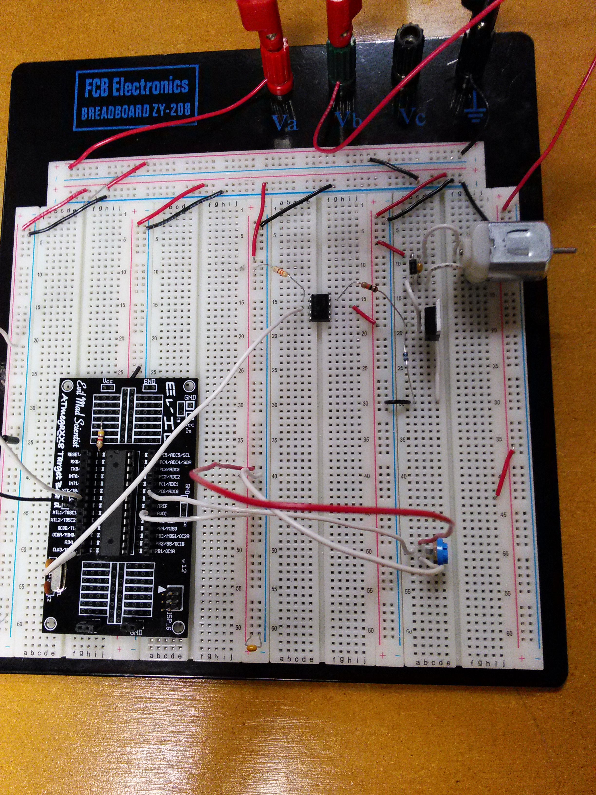

TASK 2:

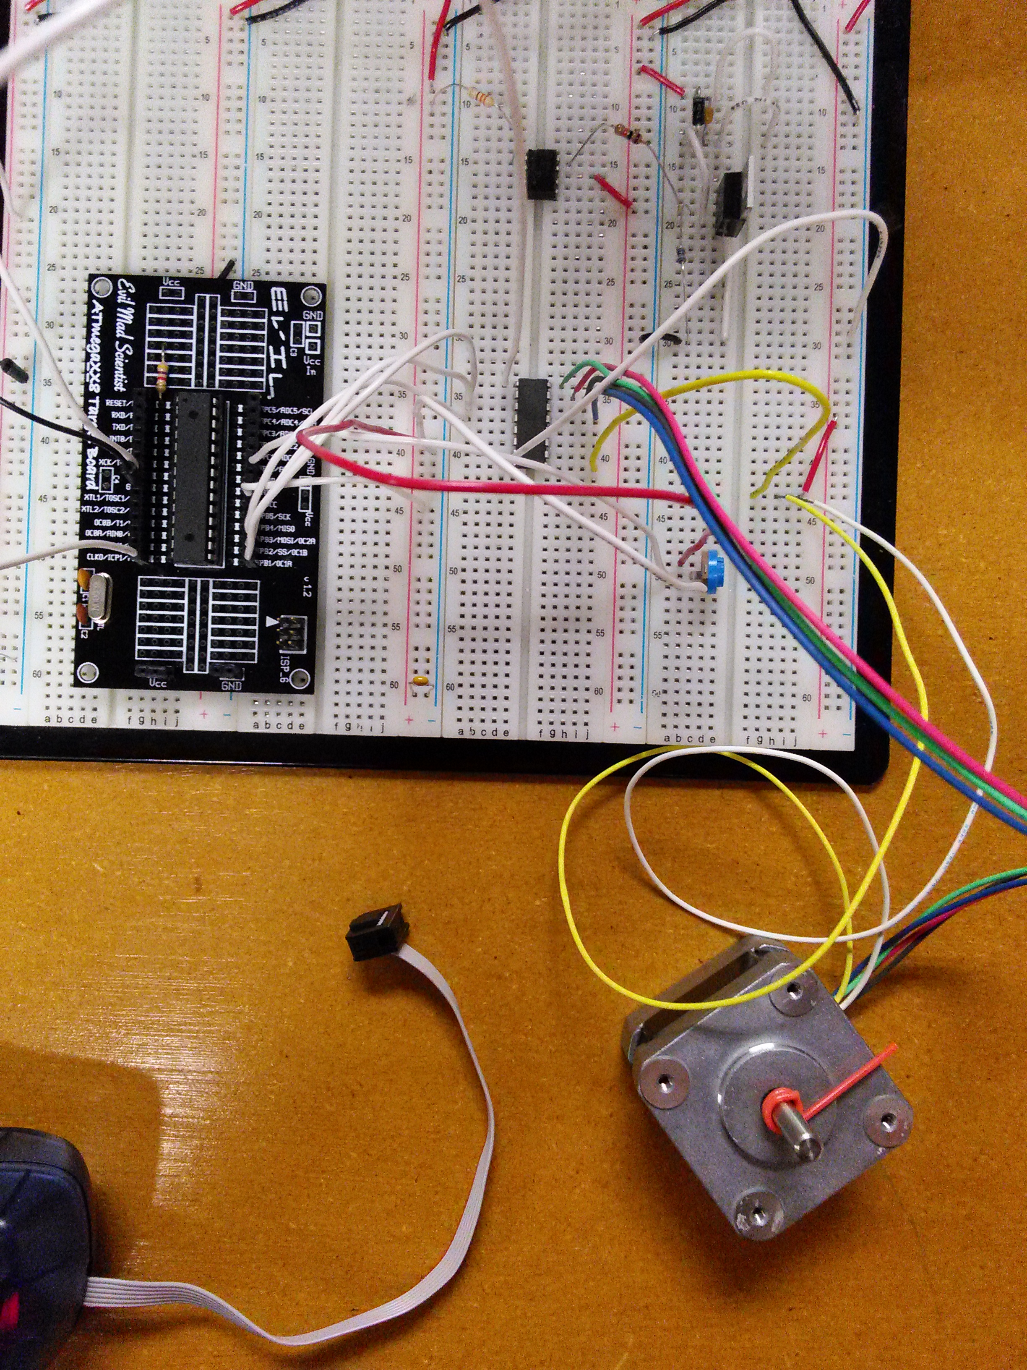

TASK 3:

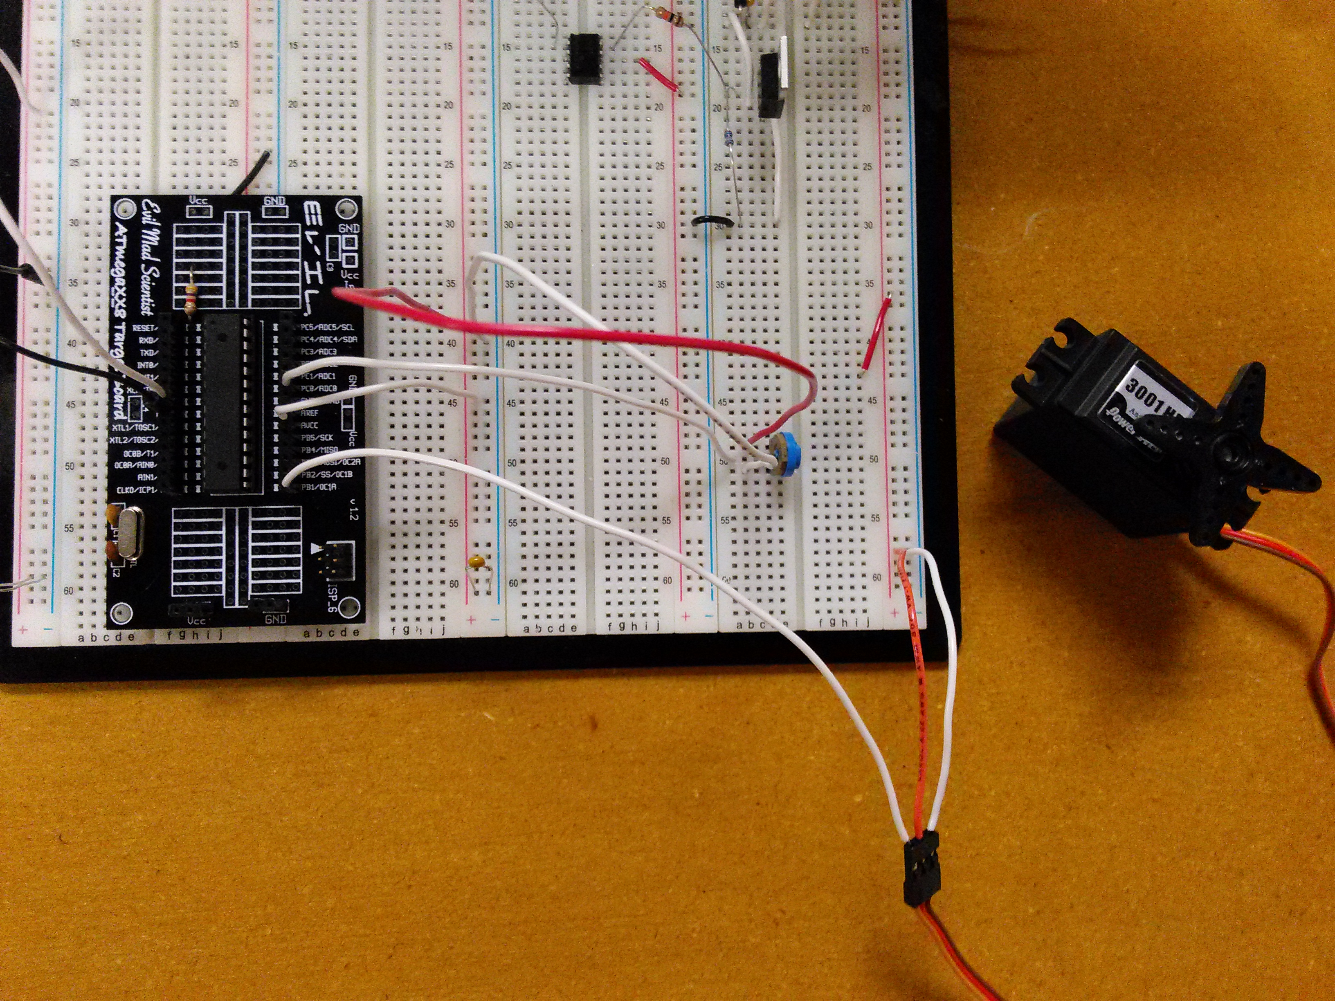

|  |  |  |  |
| --- | --- | --- | --- |
| 7. | VIDEO LINKS OF EACH DEMO |  |  |
| TASK 1: <https://youtu.be/zzia583Jv5U> | | | |
| TASK 2: <https://youtu.be/xc-3_8ahIW0> | | | |
| TASK 3: <https://youtu.be/pyqR0t9IfpQ> | | | |
| 8. | GITHUB LINK OF THE DA |  |  |
| https://github.com/michael-ghisilieri/CpE301_DAs.git | | | |

**Student Academic Misconduct Policy**

<http://studentconduct.unlv.edu/misconduct/policy.html>

“This assignment submission is my own, original work”.

MICHAEL GHISILIERI